**Lesson 5 – Marketing (Basic selling)**

**Agenda:**

* Definition of selling
* Target selling
* Attitude – make good impression
* First impression
* What makes a great sales person
* New challenge
* Value of communication

**Definition of selling**

* + Selling involves 2 or MORE persons.
  + They all want to reach an agreement.
  + Agreement needs to satisfy all of them
  + HELPING OTHERS TO DECIDE
  + Transaction between seller and prospective buyer
  + Money in exchange for goods or services
  + If you want to sell, focus on sales skills to close the deal.
  + Selling = The art of closing a deal

**Telling is not selling.**

* + The person that knows everything about his offering is an expert.
  + The person that tells everything about his offering is a nagger.

**Different kind of selling: they all have the same goal**

* + High-pressure selling: Stress
  + Persuasive selling: arguments
  + No-pressure selling: relaxing
  + Collaborative selling: exchange

**Selling does not always involve a sales person.**

* Buy gas for your car (sales build on simple needs)
* Buy a car (sales build on manufactured need) you think you need a new car because you have been persuaded to believe that.
* Marketing = selling

**Target selling**

**Importance of setting targets**

* Selling requires time, Preparation, meetings, offers, follow up….
* Selling efforts must be focused on real potential customers.
* Targets must fit with the product or service to offer.
* Targets must be clearly identified and managed.

**Selling requires time, preparation, follow up, …**

* Time: because when you rush into selling the customer will freeze
* A good preparation is half of the selling.
* Follow up: because you need to build a relationship

**Selling efforts must be focused on real potential customers.**

* + Why would you try to sell a cow to a bakery instead of a butcher?

**Targets must fit with the product or service to offer.**

* + Why try to sell an IT-student to a company without employees?
  + Who has No need for people?
  + This requires a study of the market.

**Targets must be clearly identified and managed.**

* + Do your homework
  + Do a market study
  + Build up a relationship

**ATTITUDE**

* + BE aware that your attitude and body language is being looked at.
  + This is how you will be remembered by your customer.
  + Smile! look happy at the meeting
  + Sit STRAIGHT UP on your chair
  + Don’t play with your pen/note book/PHONE
  + Don’t shake your arms and legs
  + Look YOUR CUSTOMER in the eye
  + If there ARE MORE PEOPLE, look at each of them one after the other.

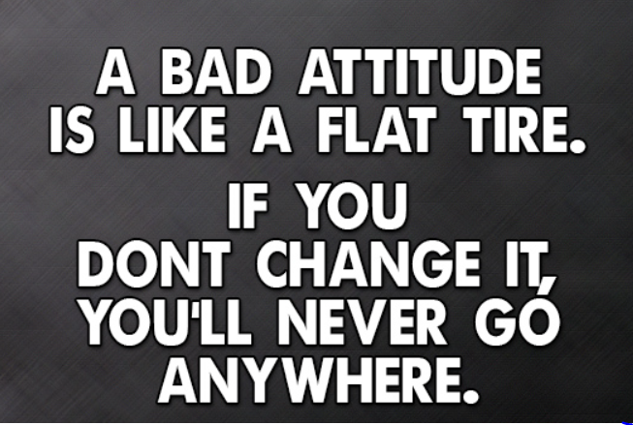

**The importance of possitive attitude**

* A positive attitude will create opportunities.
* A positive attitude will look constantly for new opportunites.
* Use your set back / negative experience as learning process

Do not promise or sell anything that you can’t deliver.

Do not lose your customer’s trust. It will take a long time to build up again.

**FIRST IMPRESSION**

* The first impression will remain forever.

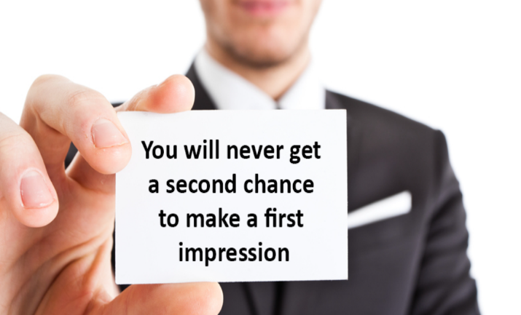

* First impression is made within 17 seconds of meeting someone
* 55% is based on appearance.
* 7% is based on the use of word.
* 38% is based on tone of voice.

Before you get sufficient time to show your skills, the first impression is already made.

First impression is often irreversable.

First impression is determined by looking fit, neat, confident, stylish and pleasant.

If you personally think this is wrong … too bad better accept it.

You can work on a first impression by:

* Practising
* Smiling
* Being relaxed
* Showing respect

**WHAT MAKES A GREAT SALES PERSON**

* Good listener
* Convincing
* CLEAN appearance
* Organised
* Product knowledge
* Humor
* Common sence

**GOOD LISTENER**: Have the ability to listen to what the customer tells you to find out what he wants to detect opportunities.

**Convincing**: Have the ability to convince by taking the lead you have to be persuading and you have to know your products.

**Clean appearance**: Always show up nicely in respect to your customer with correct dresscode to be professional

**Product knowledge**

* The person that knows his product will sell better.
* You will get more respect from the customer.
* This will be told to other persons.

**Humor**

* Be able to understand and use humor
* You can create a positive atmosphere that lightens up a conversation.

**Common sense**

* Be intelligent
* You can work yourself out of any situation.
* It shows your intelligence.

**NEW CHALLANGE**

« Everything is difficult before it becomes easy! » - HENRY FORD

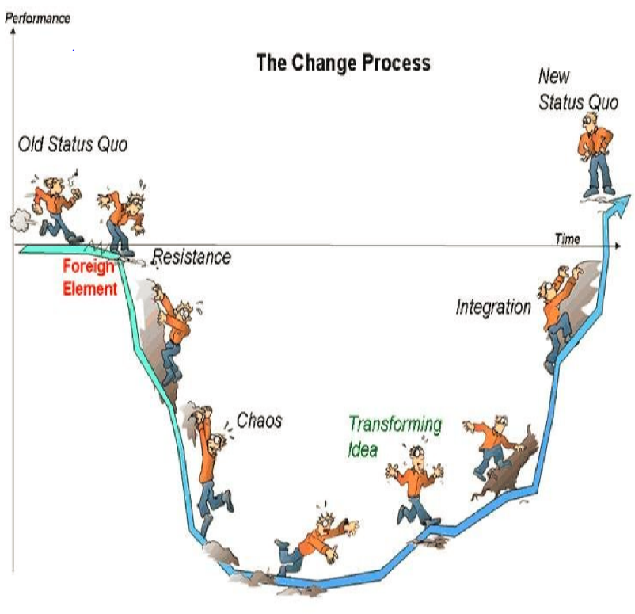

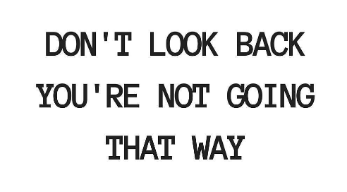

**VALUE OF COMMUNICATION**

WE need to listen … to better communication!

**Why do we need to listen better?**

* Listening to your customer will give you more understanding to better your communication with him.
* You want to speak the same language as your customer to better succeed in your selling/relationship.

Have you ever wondered why we have two ears and only one mouth?

**Talk less – listen more**:

* A salesperson should listen twice as much as she speaks and repeat back to the customer what the client said and ask for confirmation.
* Customers love to be listened to
* Taking the time to listen to your customer can set the sales professional apart from competitors who push too hard.

Be careful in your communication

* What we say
* What he understands

The value of the communication is what the CUSTOMER remembers!